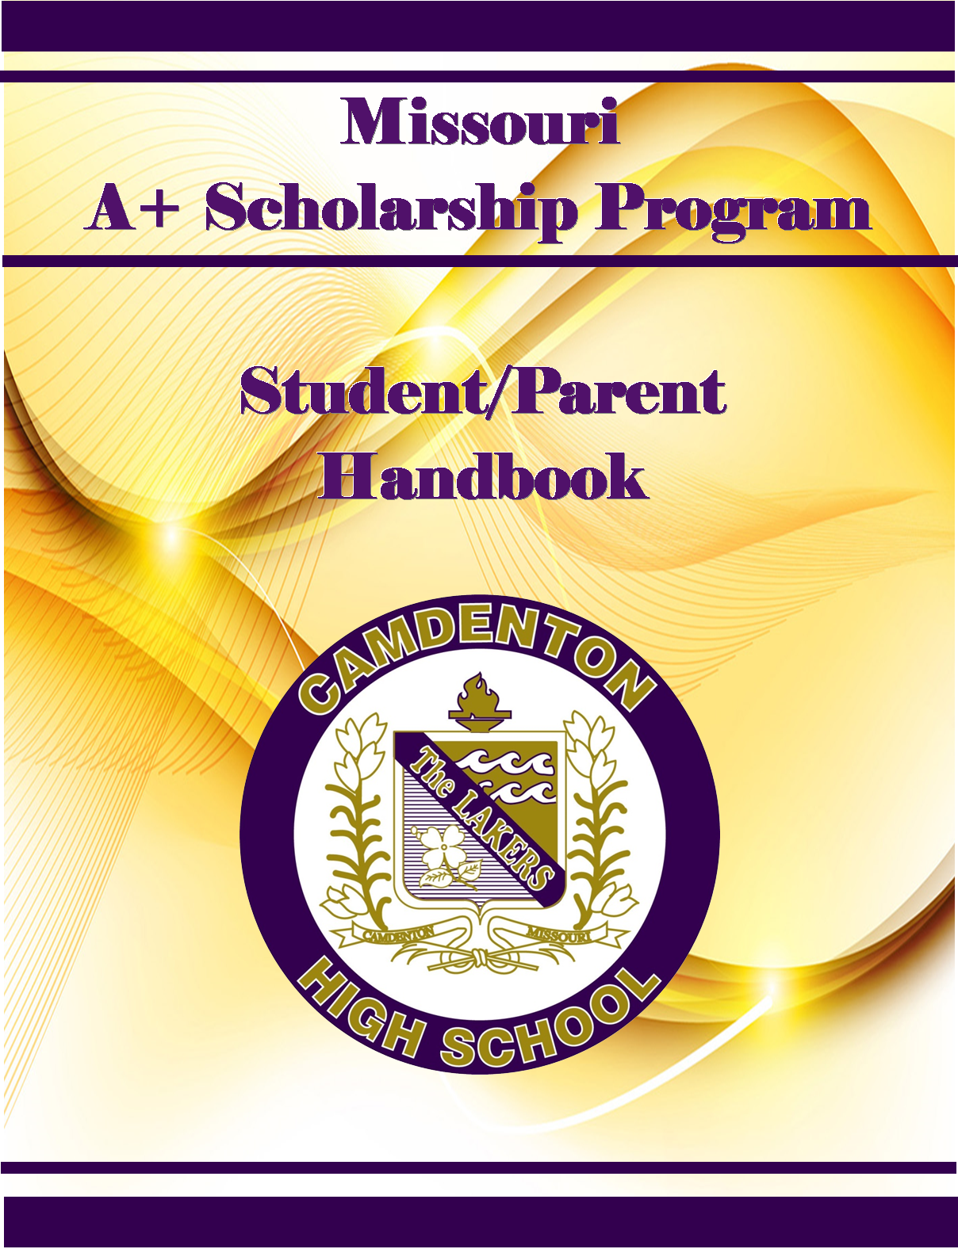

TABLE OF CONTENTS

FOREWORD
THE A+ SCHOOLS PROGRAM
GOALS OF THE A+ SCHOOL STATUS
ACHIEVING A+ SCHOOL STATUS
BENEFITS OF AN A+ SCHOOL FOR STUDENTS
STUDENT ELIGIBILTY
ENROLLMENT REQUIREMENTS
GRADE POINT REQUIREMENT
ATTENDANCE REQUIREMENT
TUTORING/MENTORING REQUIREMENT
CITIZENSHIP REQUIREMENT
FINANCIAL INCENTIVES
GOOD FAITH EFFORT TO SECURE FUNDING
PRINCIPALS EVALUATION
APPEAL FOR CITIZENSHIP CERTIFICATION
APPENDIX
ALGEBRA EOC REQUIREMENT
APPEAL OF CITIZENSHIP
A+ AGREEMENT
TUTOR/MENTOR AGREEMENT
TUTOR/MENTOR LOG
A+ SEMESTER UPDATE
NOTES

FOREWORD

The A+ Student Handbook has been written to provide you with information concerning the various aspects of the A+ Schools Program as established by the Outstanding Schools Acts of 1993.
The first step toward participation in the program is the signing of the A+ Schools Agreement, which requires the signatures of Student, Parent/Guardian, Principal and A+ Coordinator. It then becomes the responsibility of the student to continue to meet the requirements of the program as outlined in this handbook in order to be certified as an A+ Student upon graduation.
It is realized that some students will not be able to meet the requirements as set forth in the A+ Schools Program. It will be the responsibility of the A+ Coordinator to notify the student and parents immediately if it is determined a student is not eligible for A+ School status. This manual is designed to present, in a clear and consistent manner, the guidelines and policies to be followed by the A+ Student and A+ School Coordinator.
Please read the information carefully. It is provided for parents, students and employees of the district so a clear understanding of the requirements for becoming and A+ Student is achieved.
Direct any questions concerning this program to the A+ School Coordinator at Camdenton High School, 346-9226.

Melinda Whitney
A+ Coordinator

THE A+ SCHOOLS PROGRAM

The A+ Schools Program is a comprehensive program of curricular, instructional, and technological developments and improvements designed to better meet the needs of all students, regardless of whether they plan to attend a traditional four-year college, a community college, a vocational or technical school, or plan to seek employment immediately out of high school.

The program will provide for extensive curricular development, staff development, career guidance, activities designed to address the needs of at-risk students, articulation agreements with postsecondary educational institutions, and the development of applied courses that provide learning in a more real-world context.

GOALS OF THE A+ SCHOOLS PROGRAM

As outlined by the Missouri Department of Elementary and Secondary Education, the three primary goals of the A+ Schools Program are:
• All students will graduate from high school.
• All students will complete a selection of high school studies that is challenging and for which there are identified and measurable learner expectations.
• All students will proceed from high school graduation to a traditional college or postsecondary vocational or technical school or high wage job with workplace skill development opportunities.
This last goal, perhaps more than any other, exemplifies the basic purpose of the A+ Schools Program. It is essential that every student graduate from high school with the skills and tools required to pursue whatever educational and career goals the student and his or her parents select.
The A+ Schools Program will provide information to assist in making those decisions, and will provide for the development of educational programs that more fully meet the needs of all Camdenton High School students.

HOW DOES A SCHOOL GAIN STATUS
AS AN A+ SCHOOL?
The district must establish and make significant progress toward meeting district-wide performance standards regarding the primary goals of the A+ Schools Program, develop performance standards for all courses, provide for a plan to eliminate a general track of courses that lead to graduation, and develop a partnership plan with parents, business leaders, community leaders, and other educational institutions.

BENEFITS FOR STUDENTS

All students will benefit from the infusion of technology into the curriculum, the development of more effective instructional techniques, clearly stated and measurable learner expectations and graduation performance standards, more extensive career exploration and guidance activities, and the development of courses with a more real-world focus.

Each student can be assured that he or she will be required to complete a rigorous academic program that is more closely geared to his or her individual needs and interests.

STUDENT ELIGIBILITY

To be eligible for the financial incentives of the A+ Schools Program, a student must be certified as an A+ Student by Camdenton High School. The A+ Coordinator, as the official representative of the A+ Schools Program to the State Educational Department, has the responsibility to certify whether a graduate of Camdenton High School has met the criteria of the program. To be certified as an A+ Student, an individual must do the following:
• Sign an A+ Student Agreement (example included in the Appendix of this handbook).
• Attend an A+ designated high school three consecutive years prior to graduation.
• Maintain at least a 2.5 grade point average on a 4.0 scale.
• Starting with the graduating class of 2015, must have scored Proficient or Advanced on the Algebra EOC exam. (If not, student will have to meet an alternative requirement to be eligible before they graduate)
• Maintain a 95% attendance record.
• Perform 50 hours of unpaid tutoring or mentoring for other students.
• Maintain a record of good citizenship and avoidance of the unlawful use of drugs.
• Make a good faith effort to first secure all available federal postsecondary student financial assistance funds that do not require repayment.
Each student’s progress will be updated each semester and kept in the A+ Coordinators office.

ENROLLMENT REQUIREMENTS

In order to obtain financial incentives, the requirements are for a student to attend Camdenton High School for three years prior to graduation.
• The student must enroll in Camdenton High School no later than 2 weeks after the beginning of the fall term of the students sophomore year.
• If a student withdraws or transfers from Camdenton High School after the beginning of their sophomore year, the student will not be considered eligible for the A+ School Program, even if that student re-enrolls at Camdenton before graduation

GRADE POINT REQUIREMENT

To receive A+ incentives, a student must graduate with a non-weighted cumulative grade point average of 2.5 or above on a 4.0 scale. The following statements are intended to help clarify the A+ School policies concerning grade point average.
• The non-weighted cumulative grade point average is for all four years.
• The student’s official transcript will serve as evidence of grade point average for admission into a public community college or public vocational/technical school.

ATTENDANCE REQUIREMENT

The attendance rate must be at least 95% for all four years of the student’s high school career. The following guidelines will be followed:

• The cumulative attendance information given to the A+ School Coordinator will come from the official attendance record kept by the district.
• A cumulative attendance record will be kept from the beginning of the student’s freshman year until graduation.
• At the end of each semester, the cumulative attendance record will be sent to the A+ Coordinator.
• At the end of the first semester, a letter showing the cumulative attendance record information for each A+ Student will be sent to the parents.

TUTORING/MENTORING

REQUIREMENTS

The criteria of the A+ Schools Program requires students seeking A+ status must perform 50 hours of unpaid tutoring or mentoring for other students. Listed below are the A+ Schools guidelines concerning tutoring or mentoring.

• Tutoring/mentoring must be done on school premises and supervised by the District.
• The student must go through an orientation/training before the mentoring/tutoring will begin.
• The official time sheet must be picked up in the A+ Coordinators office and turned in at the end of each quarter.
• The school official in charge of supervising tutoring or mentoring must sign the official time sheet. (Example form in Appendix of this handbook)
• Tutoring/mentoring may be done during the school year or during summer school.
• The student is expected to be present at the agreed day and time for tutoring/mentoring.
• If an absence must occur, the student is expected to notify the A+ Office with the teacher/child tutoring information they are scheduled for.

TUTORING/MENTORING REQUIREMENTS CONTINUED
The following list contains possible opportunities that will count toward the 50 hours of unpaid tutoring/mentoring requirement of the A+ Schools Program. All tutoring opportunities are scheduled through the A+ Coordinator.
Elementary Schools Middle School High School (Before and After School) Project Pass Summer School LCTC Specialized 1 hour tutoring
CITIZENSHIP REQUIRMENT
This section of the handbook explains the A+ Schools requirement of maintaining a good citizenship record and avoiding the unlawful use of alcohol or drugs. The list below lists the guidelines to be used to determine citizenship requirements.
Any student wishing to be eligible for the A+ financial incentives will not sell, possess, or use any controlled substances as defined by law unless prescribed by a licensed physician.
Citizenship certification will be based upon the following:
• Discipline record of the student as determined by the Assistant Principal.

FINANCIAL INCENTIVES FOR POSTSECONDARY EDUCATION
Having attained A+ School status, Camdenton High School graduates may qualify for tuition and fees at any public Missouri community college, vocational or technical school for a period of 48 months after high school graduation.
The tuition incentives will be made available, subject to legislative appropriation, only after the student has made a documented good faith effort to first secure all available federal postsecondary student financial assistance funds that do not require repayment. The tuition incentives will only be made available to reimburse the unpaid balance of the cost of tuition, and general fees, subject to legislative appropriation after federal postsecondary student financial assistance funds have been applied to these costs.
In an age of rising educational costs, this represents a significant opportunity for the young people of our community.
GOOD FAITH EFFORT TO SECURE FUNDING
The A+ Schools Program requires students and parents to first make a good faith effort to secure all available Federal Postsecondary Financial Assistance funds that do not require repayment. Parents must complete the Free Application for Federal Student Aid (FAFSA). After approximately four to six weeks, information will be sent to your home via email/mail that must be sent to the community college or public vocational/technical school which the student is planning to attend.
Good Faith Effort to Secure Funding, Continued
• The FAFSA form is available online at www.FAFSA.Ed.Gov
• Students and Parents must file. You can file as early as October 1st.
• State of Missouri Deadline for filling FAFSA is April 1st by Midnight
• WEB filling Deadline is July 2nd

PRINCIPAL’S EVALUATION

The Assistant Principal will certify if the student continues to meet the A+ School Program requirement of good citizenship using the following criteria:
1. Character
• Demonstrates a distinctive quality of being a role model for other students
• Displays a courteous, positive, and cooperative manner toward fellow students, parents, teachers and administrators.
• Is honest in completion of school activities, assignments, and test.
• Shows respect for others and their property.
2. Ethics
• Demonstrates the ability to make responsible mature decisions.
• Displays characteristics that are based upon accepted ethical standards.
3. Responsibility
• Demonstrates responsible behavior by completing assignments, arriving to class on time, and being prepared.

Upon reviewing the cumulative discipline record of the student, the Assistant Principal will report one of the following:
• Continued certification
• Probation for a period of not less than one semester
• Withdraw from the A+ School Program
When reviewing the student discipline record, the following offenses, in compliance with the Safe Schools Act and as stated in the Camdenton High School Handbook, will result in the Assistant Principal recommending immediate withdrawal from the A+ Schools program.

Principals Evaluation, Continued

• Any act of violence within the school setting
• Using, selling, transferring alcohol, drugs, narcotics
• Possession of drug paraphernalia
• Murder
• Arson/fire extinguisher/false alarm/false 911 report
• Possession of weapon (real or look-a-like)
• Bomb threat
• Intoxication
• Forcible rape or sodomy
• Robbery/extortion/theft/possession of stolen items
• Kidnapping
• Assault
• Cheating
• Vandalism
• Trespassing
• Possession of fireworks or explosive devices
• Indecent exposure/sexual misconduct
• Gambling
• Sexual harassment
• Any act which is reported to law enforcement officials
When reviewing the student disciplinary record, the following offenses as stated in the Camdenton High School Handbook will result in the Assistant Principal recommending the student being placed on probation for a period of time not less than one semester.
• Tardiness
• Absences
• Classroom behavior
• Inappropriate behavior in the halls
• Fighting (depends on circumstances)
• Misconduct in extra-curricular activities
• Leaving campus without permission

Principals Evaluation, Continued
• School bus misconduct
• Inappropriate dress
• Inappropriate public affection
• Name calling
• Intimidation
• Graffiti

The following scale will be used for the identification and determination of character, ethics and personal responsibility in a student’s participation in the A+ Schools Program.
1. Excellent, exemplary
• Role model for other students.
• Almost always makes decisions based upon ethical values.
• Assumes responsibility for behavior at all times.
• Self-motivated, takes initiative to do extra work.
2. Above average, outstanding
• Is not unduly influenced by peer pressure.
• Makes most decisions based upon ethical values.
• Often assumes responsibility for own behavior.
• Is often self-motivated
3. Average, adequate, appropriate
• Follows the behavior of good role models.
• Makes appropriate decisions.
• Is guided to take responsibility for own behavior
• Is motivated by the enthusiasm of others.
4. Below average, below expectations
• Is sometimes led by inappropriate role models.
• Sometimes makes bad decisions.
• Does not take responsibility for own behavior
• Is often unmotivated.

Principals Evaluation, Continued
5. Poor, unacceptable
• Serves as a poor role model for other students.
• Makes decisions based on unethical values.
• Blames others for own behavior
• Refuses to work.

APPEAL PROCESS FOR CITIZENSHIP CERTIFICATION

Students and/or parents will have 30 days to appeal any decision regarding citizenship or attendance (only attendance and citizenship are eligible for the appeal process). The appeal form must be submitted in writing to the office of the principal.
Parents may make the appeal in writing and/or make a presentation before the A+ Appeals Committee. Upon receiving the written appeal, the A+ Coordinator will convene the A+ Appeals Committee. The A+ Coordinator will act as a facilitator and non-voting member of the appeals committee, composed of the following:

Teachers (2)
Guidance Counselor
Dean of Students
Principal

The A+ Schools Appeal Committee will meet to determine the certification of the A+ Student involved in the review. The principal will notify parents in writing immediately after the appeal has been reviewed and the committee has reached a decision.

APPENDIX
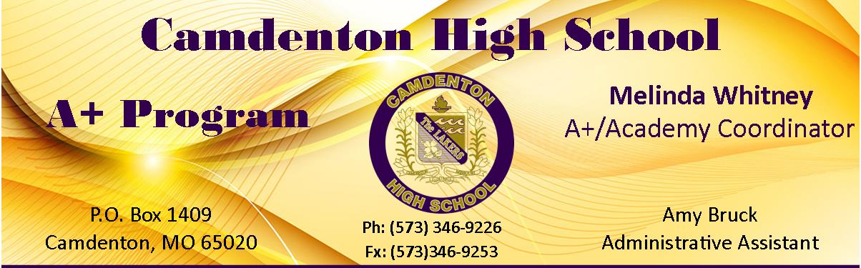

APPEAL OF GOOD CITIZENSHIP CERTIFICATION REQUIREMENTS

Student: Date:

Parent/Guardian: Phone:

Address:

City: Zip Code

Graduation Year: Date Received: (office use only)

Appeals Hearing Scheduled for:

In the space provided below, please indicate the basis of your appeal concerning the certification for good citizenship requirements for reaching A+ Student status.

Camdenton High School
A+ Student Agreement

Camdenton High School has been designated as an A+ School. All eligible students at Camdenton High School, regardless of income, who meet all the criteria listed below have the opportunity to receive funding for the unpaid balance of the cost of tuition and general fees, subject to legislative appropriation, for a period of 48 months after high school graduation to any Missouri public community college, vocational or technical school after federal post-secondary financial assistance funds have been applied. This is contingent upon the students meeting all of the following responsibilities:

Responsibilities at CHS are:
- Have attended an A+ designated school for 3 consecutive years prior to graduation.
- Graduated with a cumulative grade point average of 2.5 on a 4.0 scale. (non-weighted)
- Have at least a 95% attendance record for the four (4) year period.
- Performed fifty (50) hours of unpaid tutoring/mentoring for other students.
- Maintained a record of good citizenship (see Camdenton RIII Student Handbook) and avoidance of the unlawful use of drugs and or alcohol. (The complete citizenship policy is in the Camdenton R III Student Handbook).
- Males register for Selective Service, if over the age of 18
- Secure all available federal student financial assistance funds that do not require repayment through the Free Application for Federal Student Aid (FAFSA) on line.
- Qualifiers must achieve a score of Proficient or Advanced on the Algebra I End of Course exam.

The financial incentive is available only after the student has made a good faith effort to first secure all available federal financial aid through the Free Application for Federal Student Aid (FAFSA) that does not require repayment.

Post-Graduate Responsibilities: To maintain eligibility, each participating student, during the four (4) year period of incentive eligibility must:
- Have enrolled and attended on a full-time basis a Missouri public community college or vocational/technical school.
- Maintain a grade point average of 2.5 or higher on a 4.0 scale
- Make a good-faith effort to first secure all available federal postsecondary student financial assistance funds.

To be eligible each student must enter into a written agreement with the school.
Agreement:
I understand that if I successfully meet the above criteria, the State of Missouri may provide funding for the cost of tuition and general fees, subject to legislative appropriation for a period of 48 months after high school; completion of 105% of the hours required for the program; or receipt of an associate’s degree, to any Missouri public community college, vocational or technical school. I have been informed of the conditions for eligibility and understand the criteria as they apply to the A+ Schools Financial Incentives outlined in the A+ Schools Program.

Student Name (Please Print Legibly) Year of Graduation

Student Signature/Date Parent or Guardian Signature/Date

A+ Coordinator Signature/ Date Principal Signature/ Date

Tuition reimbursement and eligibility requirements are contingent upon state legislation and funding and are not the responsibility of Camdenton Public Schools.
A+ Program Tutoring/Mentoring Availability Form

Student: ________________________________________________ Grade: ________________

I am presently a tutor for: (Please check all that apply)
- Academic Lab
- Freshman Mentor
- Intervention
- Individual Tutoring (list building) __________________________
- Project Pass in (list building) ______________________________

High School Subjects available to tutoring/mentoring: (Please circle all that apply)
Math: Pre-Algebra Algebra I or II Geometry
Trigonometry Calculus Statistics Pre-Calculus
Science: Environmental Science Chemistry Biology Physics Anatomy/Physiology
History: World History American History Government Other:______________
English: 9th 10th 11th Other:___________________________
Foreign Language: French I French II French III French IV
Spanish I Spanish II Spanish III Spanish IV
College Courses: _____________________________________________________________
IB Courses: __________________________________________________________________
AP Courses: __________________________________________________________________
Days and Hours available for tutoring/mentoring:
Before School ___________ After School _________ Study Hall___________
Days Available: Monday Tuesday Wednesday Thursday Friday

Middle School-After School tutoring/mentoring:

Elementary- After School tutoring/mentoring:

I prefer to do my tutoring/mentoring in Summer School: yes or no (Please circle one)

A+ SEMESTER UPDATE

At the beginning of school year and again at the end of the first semester, parents/guardians will be informed by letter of G.P.A., attendance percentage, and tutor/mentor hours earned.

A+ Status Update

Student: _______________________________ Date: _________________

Certification of a Camdenton High School student for A+ status depends upon a number of factors set forth by the A+ Schools Program criteria as defined by the Outstanding Schools Act of 1993. This letter will serve as the official document of record for your son/daughters’ progress toward achieving A+ Student Status.
Yes No

Must have attended an A+ designated High School

for three years prior to graduation

Must have signed A+ Agreement on file

Scored Proficient or Advanced on Algebra EOC exam
(If “No” student will have to meet an alternative requirement
to be eligible before they graduate)

Must complete 50 hours of tutoring/mentoring «Hrs» Hours

Must maintain a cumulative 2.5 (Non-weighted) GPA «GPA» Non-weighted GPA

At this time your son/daughter meets the A+ 95%

attendance requirement

The information provided is the current on file as of_______. If you have any questions please contact the A+ office at (573) 346-9226.

Melinda Whitney
A+/Academy Coordinator

NOTES
___________________________

